Insights on Individual End-users of
Resham Sutra Silk Reeling Machine

● Individual Owner cum user
- Name - Prashanna Kumar Das (45, Male)
- Location - Gopalpura, Prathmakhandi, Jajpur District, Odisha
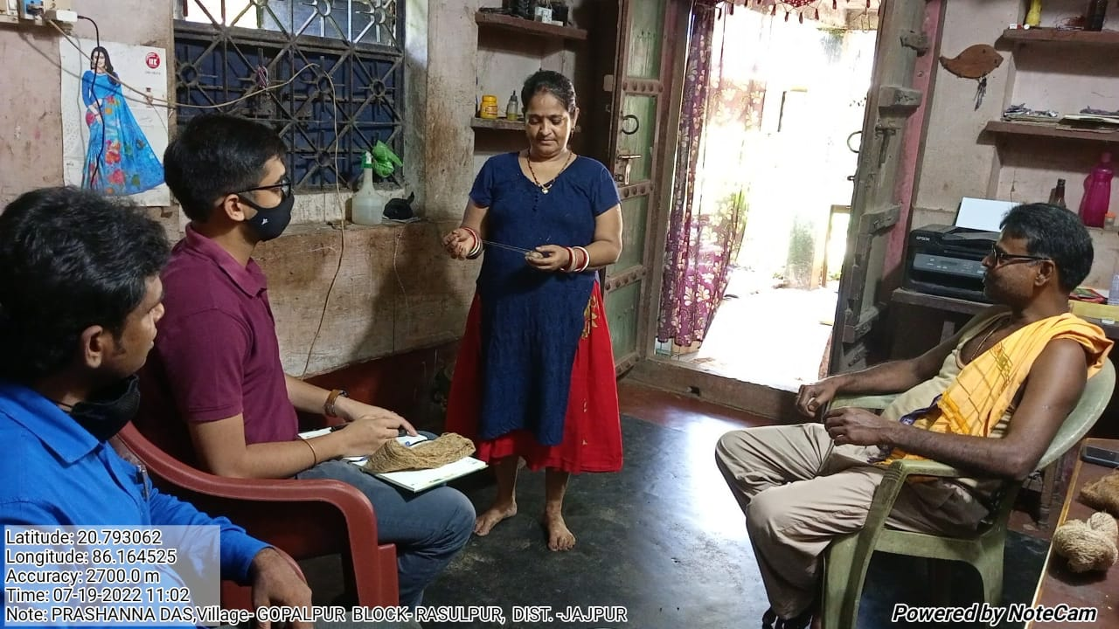
- The user’s main occupation is textiles, with silk reeling and operating looms being the major livelihood activities. It has been in practice for many generations in his family.
- The user reported that the Buniyaad Micro reeling machine was bought at around Rs 13,000 and has been used for at least seven years.
- The user reported challenges with the current procurement process of cocoons set up by the government.
- Typically, in a year, the cocoons are available in the months of Feb/Mar and Jul/Aug. They are sourced from the regions of Mayurbhanj & Keonjhar.
- User spends around Rs 4,000 for procuring about 1 kg of cocoons (~1000 numbers).
- Feedback on the Buniyaad machine from the user included a lack of quality (twisting issue) in the yarn; moving parts inside the machine are of plastic - continuous usage needs good quality metal parts.
- The women users who did the reeling manually observed a productivity improvement. While doing it manually, they could work on material worth 150 per day; now, with the machine, it has improved to Rs 300 per day.
- But he mostly opined that issues with raw material availability are his primary concerns.

- Name – Kamdev Guin (45, Male), Sabitri Guin
- Location - Fakirpur, Jajpur District, Odisha
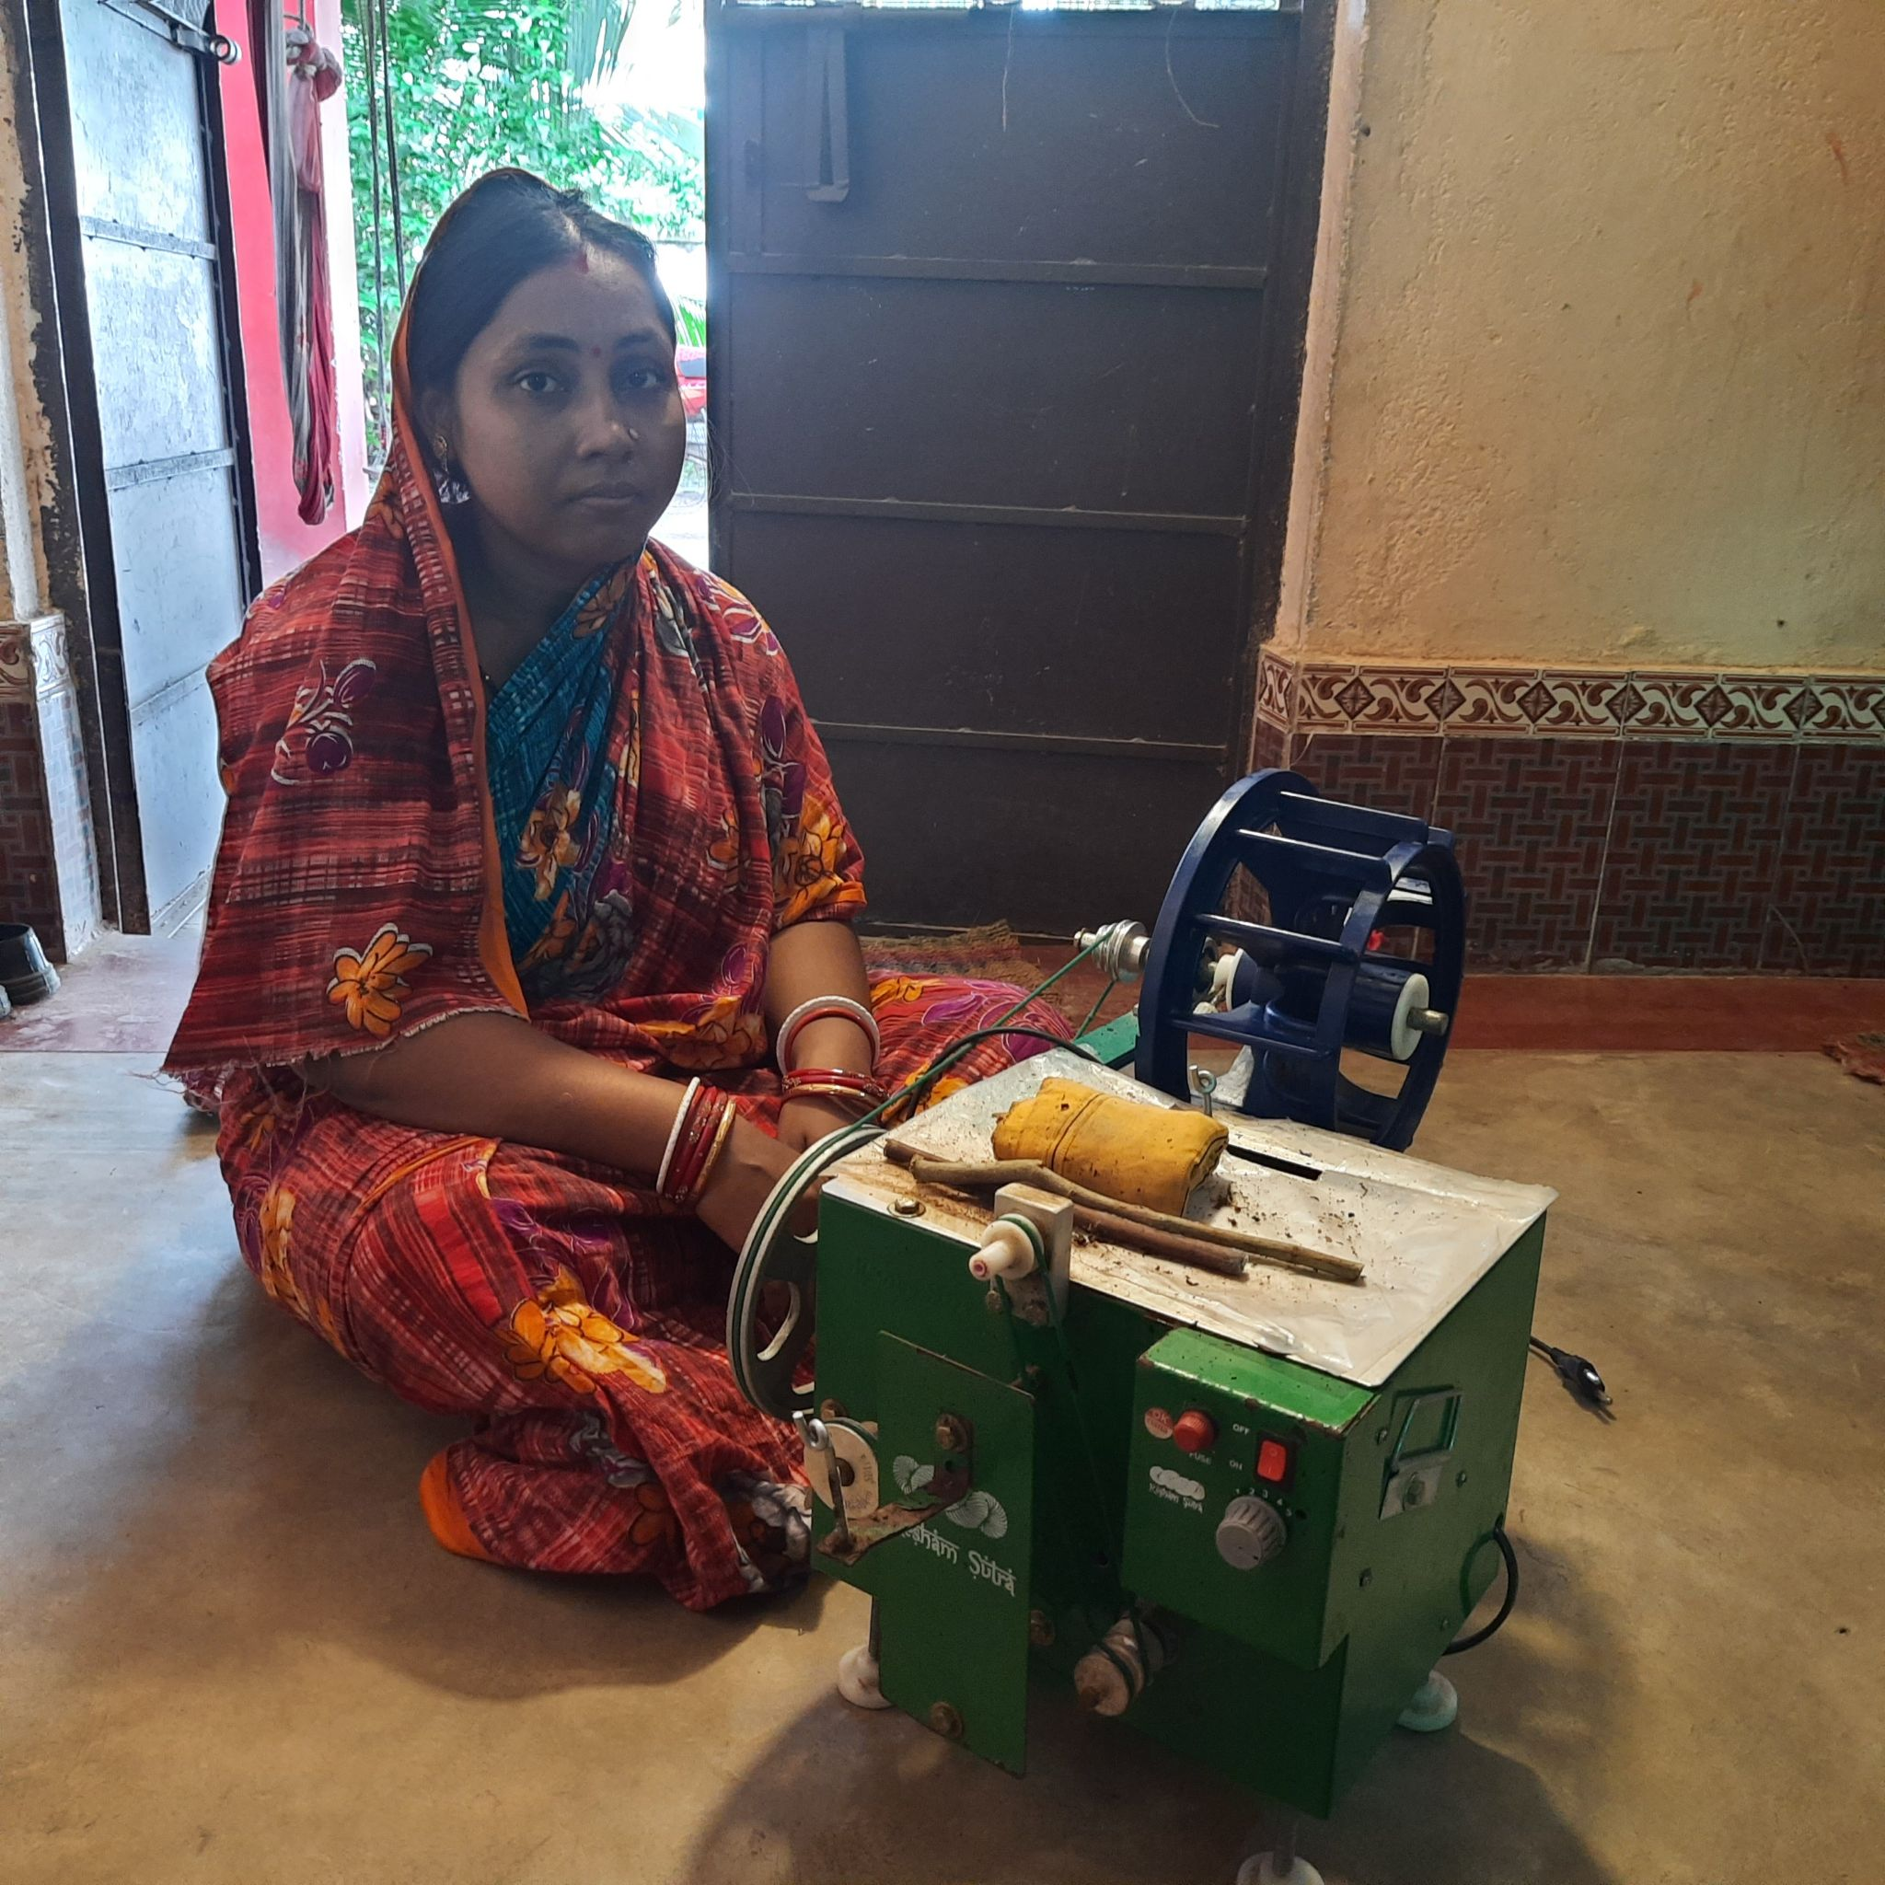
- The user claimed that the Buniyaad Micro Reeling machine was bought sometime in 2020 with an end-user contribution of around INR 2200 while the rest was subsidised (around Rs 10,000).
- In this case also, the user benefited from the machine. It was operated for around 4 hours a day. While previously the user made around Rs 250 per day, it increased to Rs 500 per day.
- But the machine got an issue for which they got it repaired with a local electrician, after which it has been subject to small electric passing during operation, leaving the user sceptical about its usage.
- Here also end-user reported issues with raw material availability and intermediaries taking a large chunk of profits. If raw material availability is sorted, the end-user is interested in taking another machine to help with the reeling.

● Individual end-user
- Name - Maa Tarini Reeling Group (Jagannath Guin)
- Location - Fakirpur, Jajpur District, Odisha
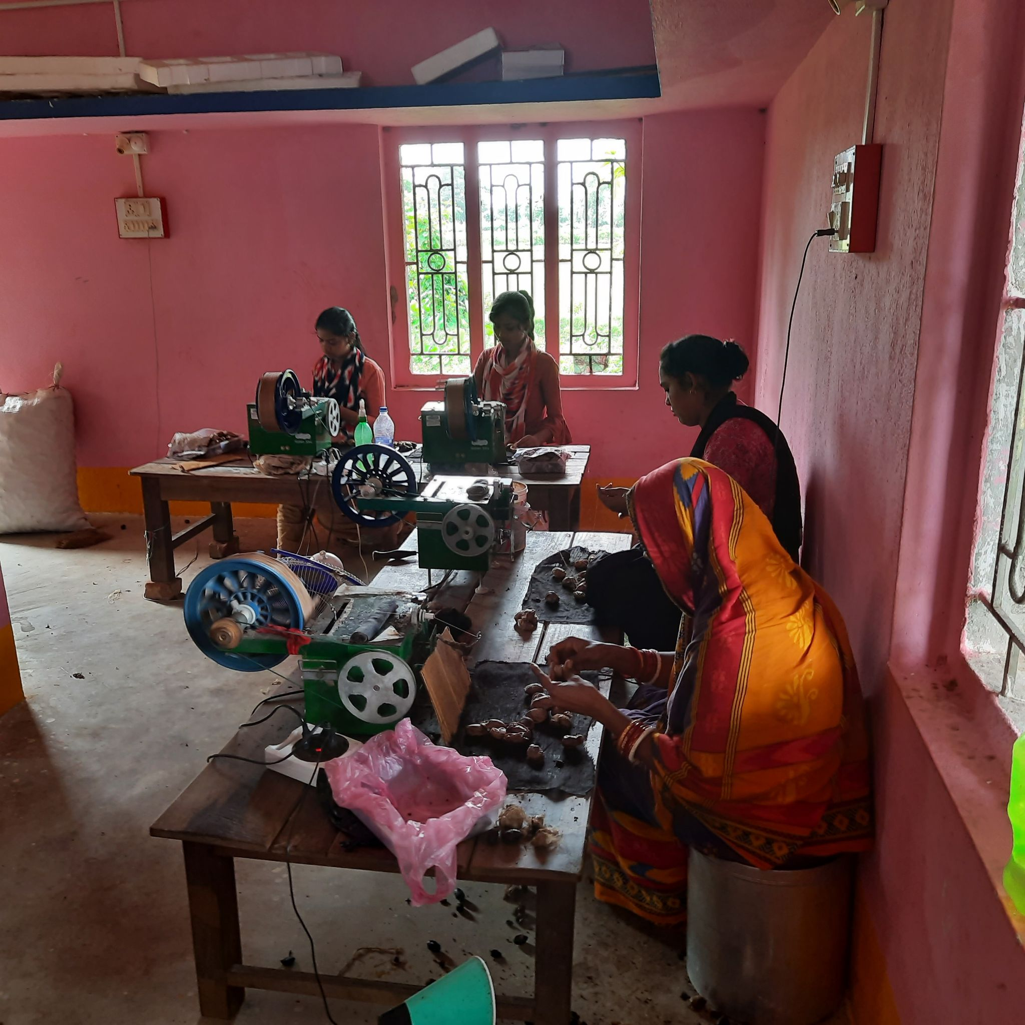
- This group was established in 2017. Initially, the process was done manually, but now the group has procured 15 Buniyaad machines (Availed Govt. subsidy up to 90%)
- It employs 16 women who work shifts of 9 AM – 1 PM and 2-6 PM. The women in the initial stages get around Rs 3,000/month, while it goes up to Rs 5,000/month with time.
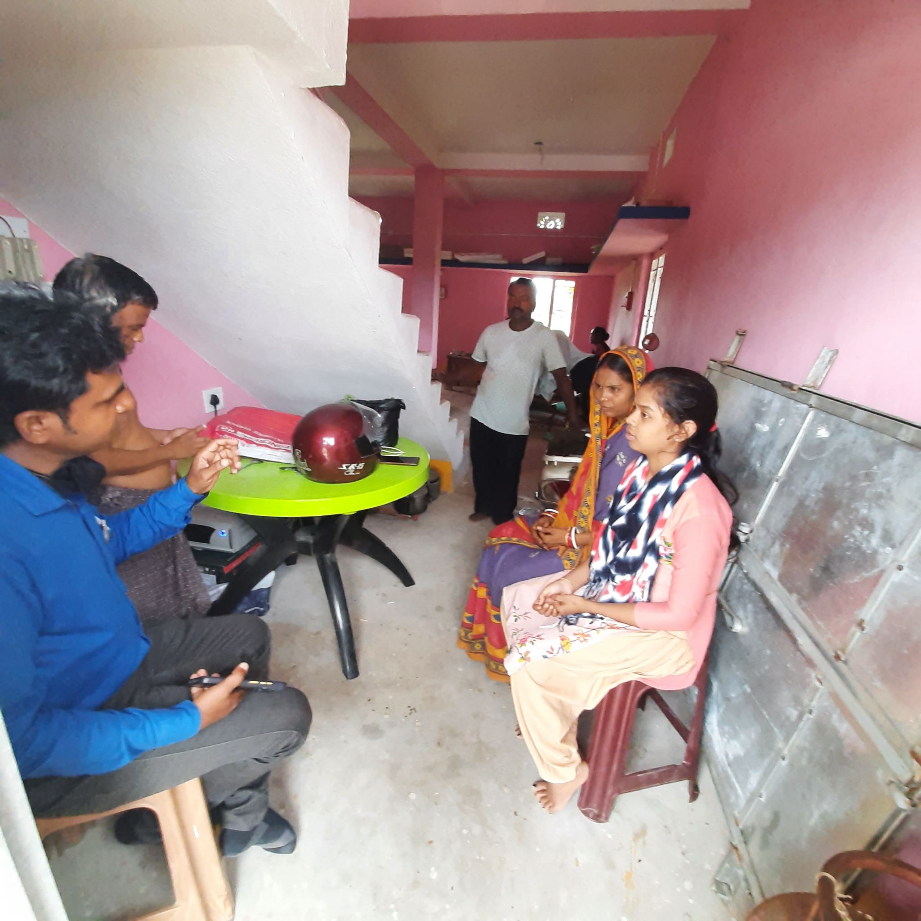
- On speaking to women employed at the centre, they claimed that working at this centre gives confidence that they too can earn some income.
- And if things go well, they could get such a machine at home to manage household chores and the reeling work.

